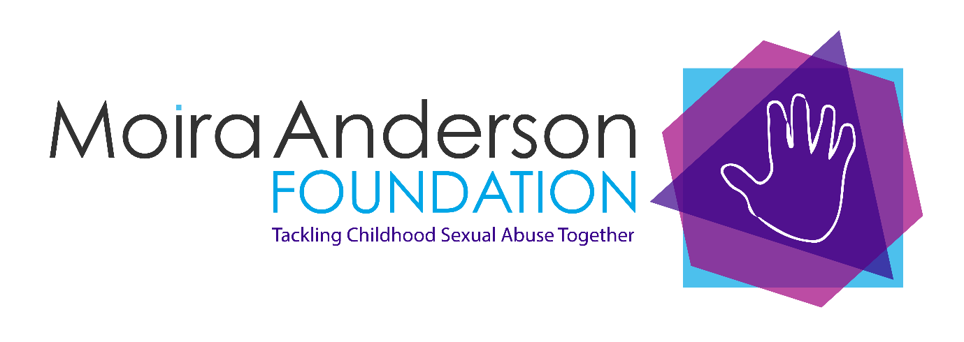

Fundraising Guidance for MAF Supporters

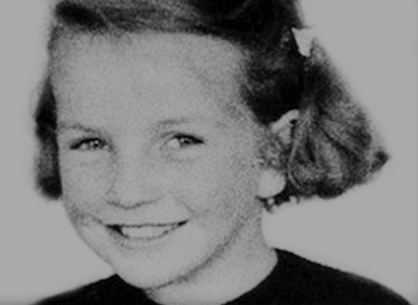

The Foundation is named after Moira Anderson, a Coatbridge girl who went missing in 1957. The foundation is her legacy. You can read about her in Where There is Evil, written by Sandra Brown OBE. Sandra founded MAF in her honour.

THANK YOU FOR CHOOSING MAF

We are delighted that you are raising funds for Moira Anderson Foundation (MAF). This guide is to help you make your events as successful as possible. This booklet provides information about our work. Our charity number is on the cover. You’ll need that for any advertising.

The Moira Anderson Foundation was set up in 2000 to provide support to children and adults affected by childhood sexual abuse. It was a daring project. Few people spoke about childhood sexual abuse and some people even doubted that there was a need for such a charity. How wrong they were.

Each year MAF has seen demand for services grow. Some adult clients were abused in childhood, others are parents, partners or siblings. We see children. That’s a sobering fact. Childhood sexual abuse is not something that happened in the past. It’s happening now. It’s happening in our communities. Children affected need skilled, compassionate and expert support.

We offer open ended support to children and young people. That means we are there for them whenever they need us not just for a fixed number of sessions. Children and young people are supported in a way that is appropriate to their age and circumstances. Some might engage in counselling; others in play therapy or art therapy. All have a named person in MAF who offers support when needed.

Adults are also supported with a named person who gives them information, practical and emotional support. Adult clients might participate in counselling, complimentary therapies, Hands on Health self-management course or a support group.

We listen; we care, and we work with the client. We never impose, or ask people to tell us their story, though many people do. Together with the client we identify how the abuse affects them in day-to-day life and together we develop strategies for managing a range of trauma related issues.

We are always seeking to raise funds. We do this from grants and trusts and from fund raising activities. We are grateful to each and every contributor. They help us to provide our much-needed services.

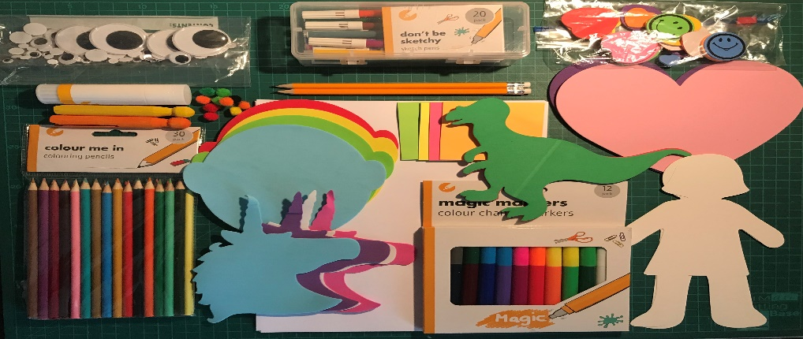

Children’s Art pack

**Having fun, raising money and staying legal!**

In all fund-raising activities we recommend you are up to date with relevant health guidance and ask yourself – how can I do this and ensure people’s safety? Including your own.

**Collections**

Collection cans at private business premises, (shops, takeaway businesses and places of work) can bring in significant donations. Collecting house to house or business to business is subject to strict regulations therefore we do not endorse this type of collection.

We have collection buckets and collection cans that are sealed; have our logo and charity number clearly displayed. You might like one for your place of work or a favourite venue.

**Raffles, lotteries and prize draws**

These need a licence unless held at an event. Check with your local authority if you want to hold a raffle, lottery or prize draw before you get tickets printed!

**People’s personal details**

If you are taking people’s personal details you need to comply with data protection. This means you do not hold, share or use information given for any purpose other than the one specified. Shred or delete people’s personal details when it is no longer required. This is really important.

**Food Hygiene**

If any of your activities involve food preparation or storage, please take care to keep others safe and use up to date food hygiene guidance. This includes bake sales, coffee mornings and tea parties.

**Insurance**

You may need public liability insurance for a publicly held fund-raising event. If you use a venue, they are likely to have insurance for venue users. You can check with them. If you are joining a large public event the organisers are likely to provide insurance but it’s worth checking. If you are holding your own event and you are unsure if you need insurance, speak to an insurance broker.

**Risk Assessment**

We would always recommend completing a risk assessment. Ask yourself, who could be harmed and how could that happen. Putting remedies in place will help you make your events safe.

**Pandemic**

It is worth checking public health advice when organising an event. This helps keep everyone safe.

**Do you shop on-line?**

Funds can be raised for MAF with no cost to the shopper.

We are registered for Easy Fundraising, a shopping site. www.easyfundraising.org.uk

You select us as your chosen charity and they do the rest. Just remember to shop through easy fundraising for us to receive your gift.

**Text**

We have text giving set up and this can be a simple way for friends and family to donate at a fundraising event.

To donate £1, text MAF2020 to 70201

To donate £3, text MAF2020 to 70331

To donate £5, text MAF2020 to 70970

To donate £10, text MAF2020 to 70191

Please be assured every pound counts and if you are a tax payer and sign up for Gift Aid your £1 is worth £1.25 to us. You get the option to sign up for gift aid on text giving.

**Sponsored Events**

We have had people run, walk, climb and do squats to raise money for MAF. If you want to raise money in this way we may be able to give you a t-shirt or zipper with our logo (items need to be returned after the event) and promote your event on our social media. We have a Just Giving Page. Donations and sponsor money can be paid directly through Just Giving. You can also set up your own page for your event at justgiving.com – Just Giving do the rest. If you want paper forms, we can provide these. They ask for details so we can claim gift aid.

**Events**

There are all kinds of events that supporters can organise such as a table top sale in their garden, bake sale, coffee morning, quizzes and fancy-dress events. We are sure you can think of something that would work for you and your group of friends. If you organise an event you can introduce additional funding raising activities at the event, such as a raffle, tombola or games. Tickets for these activities can only be sold at your event, unless you have a licence from your local authority.

**Charity number and Logo**

We can share our charity number with you, it’s on every page of this guidance pack. We may be able to share our logo but you would need to seek permission first. It is however, on our Just Giving page, so people can check us out.

**Gift Aid**

Every pound matters to MAF. Gift Aid allows us to make an extra 25p on every pound raised. So if you raise £100 we will receive a total of £125. Using Just Giving enables supporters to opt into Gift Aid. However, if you have the person’s name and address and their permission for us to seek gift Aid from the His Majesty’s Revenue and Customs, we can do that. We can provide sponsor forms that ask for Gift Aid too.

**Where do you work or study?**

Many businesses, schools, colleges and universities like to support charities. Would your organisation like to support MAF? We are based in Airdrie, but also have a Hub in Buchanan Street, Glasgow and provide online services to people from all areas of Scotland. Please consider approaching your organisation to hold an event or fund raising activity for MAF.

**Sponsorship**

MAF holds public events, such as our annual lunch. Perhaps your organisation would like to sponsor our event in exchange for some advertising opportunities at the event and promotion on our social media. If you have an idea or want to sponsor MAF we would like to hear from you.

**Paying a donation to MAF**

If you have a cash donation it can be paid directly into our bank account. We can give you details and a reference, so we know who has donated to us. **Call reception on 01236 602890 for details.**

If you still have a cheque book, we would happily receive a cheque and

we will pay that into the bank for you. If you are sending a cheque please tell us who you are and how you raised the money and how we can contact you, to thank you. If you prefer to quietly donate that’s okay too. Some people do. Our postal address is:

**3 Mavisbank Street,**

**Airdrie**

**ML6 0JA**

**Donating online**

Some people like to donate on-line. We have opportunities to donate on our website. You can donate to our Just Giving page or through PayPal.

<https://www.moiraanderson.org/>

Just scroll down and you’ll find the donation options.

**Thank you**

We are grateful for all money raised by supporters and their friends. It does make a difference. The money we get from trusts and grants covers running costs of MAF but we are dependent on getting additional funds from the public and businesses to ensure the level of service meets the growing demand.

**Fundraising Activities – Terms and Conditions**

Thank you for your interest in raising funds for Moira Anderson Foundation. We’re delighted that you have chosen to support our charity. For legal purposes, we require that you read and comply with these terms and conditions as they apply to all voluntary fundraising activity carried out in our name. You will be carrying out fundraising activities as an independent supporter of MAF and should therefore use the term “in aid of Moira Anderson Foundation”. As an independent supporter, you must comply with our terms and conditions for fundraising activities. MAF are not responsible for any costs, taxes or expenses incurred or arising in connection with your fundraising activity and any risks arising out of your fundraising activity are your responsibility, including liability for any injury or loss which may occur to you, your helpers or guests. You should take all reasonable precautions to protect the health and safety of all those participating in, involved with or attending your activity as MAF insurance will not cover your fundraising activity. You should comply with applicable laws and regulations relating to your fundraising activity, including obtaining any necessary licenses, consents or permissions e.g. if you are holding a raffle or lottery, or are proposing to sell alcohol. You should not do anything that threatens or damages MAF’s reputation or name, or that might be considered offensive to those affected by childhood sexual abuse. If you do, we reserve the right to ask you to cease your fundraising activity with immediate effect. You are required to pay all proceeds raised by your fundraising event to MAF as soon as possible after the event and at latest 28 days following the event, unless otherwise agreed. Payment must be as per our payment guidelines – details of which are outlined above. No costs can be deducted unless agreed in writing with MAF in advance. Where appropriate and where eligible, you should encourage gift aid declarations - this may enable us to recover basic rate tax on such donations. Details about Gift Aid are included in this pack. You may use Moira Anderson Foundation name and our logo, with out expressed permission, for your fundraising activities. You can apply for permission to use our logo but you need to tell us how you propose to use it and provide us with examples and/or samples of such use if we request it. You should also quote the charity’s registration numbers. We would be delighted to publish your photographs/videos in recognition of all your hard work. However, when providing photographs or videos taken during your fundraising activity, you agree that these may be used by MAF for commercial and/or fundraising purposes. By sending these to us, you are confirming that anyone featuring prominently in the photograph or video is aged 16 or over, and that they have consented to their image being used in this way. You agree that MAF can use the details that you have provided to us to discuss your fundraising activity and to follow up on your progress. If you are under 18, you confirm that you have shown these terms and conditions to your parent/guardian and they have agreed to accept responsibility for complying with these terms and conditions.